|  |  |
| --- | --- |
| 2026  CEO project PROPOSAL |  |

# 01

## Executive summary

* The problem
* The solution at a high level (platform)
* Why this matters now
* Try tie down to the 6Cs
* Stakeholders

## MEET THE Dream team

This is a table, so just insert a picture in the cell above your name

|  |  |  |  |  |
| --- | --- | --- | --- | --- |
|  |  |  |  |  |
| ALKA  SEWRAJ | MORRIS  NKOMO | MULISA  MATODZI | NEIL  SMIT | TAAHIR  KOLIA |

## Hidden Failure in everyday banking

Many debit order failures are caused not by insufficient funds, but by timing mismatches within the payments system including settlement delays, cut-off times, sequencing of debits, and differences between ledger and available balances. These constraints are largely invisible to customers, even when they have deposited funds in advance or expect known inflows on the same day.

As a result, customers experience bounced debit orders for essential obligations such as insurance, utilities, and subscriptions, leading to penalty fees, service interruptions, and repeated support interactions. From the customer’s perspective, these failures feel arbitrary and unfair, particularly when reasonable steps have already been taken to meet the payment.

Current banking tools at FNB are reactive and primarily respond after a failure has occurred, offering explanations rather than increased visibility and control beforehand. This creates a recurring gap between customer intent, system timing, and payment outcomes, turning predictable operational constraints into avoidable negative experiences.

When timing mismatches cannot be resolved through prevention alone, because inflows are genuinely insufficient at the moment of processing, the failure shifts from a payment orchestration problem to a short-duration liquidity problem.

------------

nav»Money already identified individual customers and SMEs who are entering short-term shortfall positions based on cashflow patterns, upcoming debit obligations, and expected inflows. When these shortfalls materialise, customers are presented with existing credit mechanisms such as traditional overdrafts, temporary loans, or facility increases.

However, these mechanisms are designed for general-purpose, or longer-duration liquidity needs, not for the small, predictable, and time-bound shortfalls that nav» identifies in advance. As a result, customers must either accept disproportionately large or open-ended credit facilities, wait for approval while payments fail, or manually intervene, creating friction even when the risk is low, and the recovery is highly certain.

For individuals, this leads to unnecessary fees, over-borrowing, or payment failure despite clear evidence of imminent inflows. For SMEs, the same misalignment can disrupt payroll, supplier payments, or service continuity, with outsized operational and reputational impact relative to the size and duration of the shortfall.

The market gap is therefore not the absence of credit, but the absence of a precise, time-bound, and purpose-limited mechanism that aligns with shortfall scenarios already visible to the bank

* Timing mismatches vs affordability (a visual timeline depicting typical failure would be nice here)

Simple problem statement (LMK)

Customers often forget about upcoming debit order payments because they are not reminded of. In some cases, customers also have insufficient funds at the time of the debit. These factors contribute to failed payments, penalty fees, and customer frustration. For banks, this results in more disputes and additional administrative work.

## Solution

Debit order reminders sent through the FNB app (and later the FNB WhatsApp channel) and if FNB identifies that a customer is likely to have insufficient funds based on their spending patterns, the bank could proactively offer an overdraft facility. Customers would be able to apply directly through the app and receive timeously feedback before the debit order is processed, hence equipping customers to handle their finances more effectively.

## How does this solution benefit FNB?

By giving customers timely debit order reminders and providing them with a quick way to access a small overdraft when they are at risk of missing a payment, customers become more informed and better able to manage their finances. This support helps reduce failed debit orders and gives customers a better chance of maintaining a positive credit record. As their credit scores improve, they become eligible for additional credit products such as home loans and vehicle finance, which ultimately brings more business to FNB.

Furthermore, offering flexible repayment options—either upfront or in short-term installments—FNB can generate additional income from the associated interest on these overdraft repayments.

## Research

This section presents the empirical findings derived from the survey data collected to justify this study. The dataset, *Debit Order: The Early Bird That Took My Money.xlxs****,*** containts 29 complete responses and provides insights into customer experiences, challenges, and perceptions relating to the debit order processing. The findings directly support the identified problem space and validate the need for **Flowgaurd**, a predictive overdraft and debit-order intelligence system.

### 6.1 Prevalence of Debit order failures

Nearly half of respondents (48.3%) reported that they had experienced a debit order failing despite having planned adequately (“Yes”: 41.4%, “Maybe”: 6.9%) A further 41$ reporting experiencing failures “Rarely”, 17.2% “Sometimes, and 10.3% “Often”, indicating that debit order failures, while varying in frequency, are a persistent issue across the customer base.

This demonstrates that debit order failure is not an isolated pr0oblem but a common consumer experience requiring intervention.

### 6.2 TIMING ISSUES AND Visibility GAPs

The survey revealed significant confusion and unpredictability around debit order timing:

* **37.9%** of respondents indicated they are **caught off-guard** by debit orders going of when they don’t expect it.
* **31%** reported that debit orders sometimes go **earlier or out of sequence**.
* A combined **69%** of respondents either **do not understand** or are **uncertain** about why some debit orders go through and others do not.

Critically, visibility plays a substantial role in the customer experience. Among respondents who felt they did not have enough visibility, 66.7% were caught off guard by debit orders. IN contrast, only 15.4$ of those who felt they did have visibility experienced the same issue. This presents a 52-percent-point difference illustrating visibility as a key predictor of customer difficulties.

### 6.3 Categories of debit orders most likely to fail

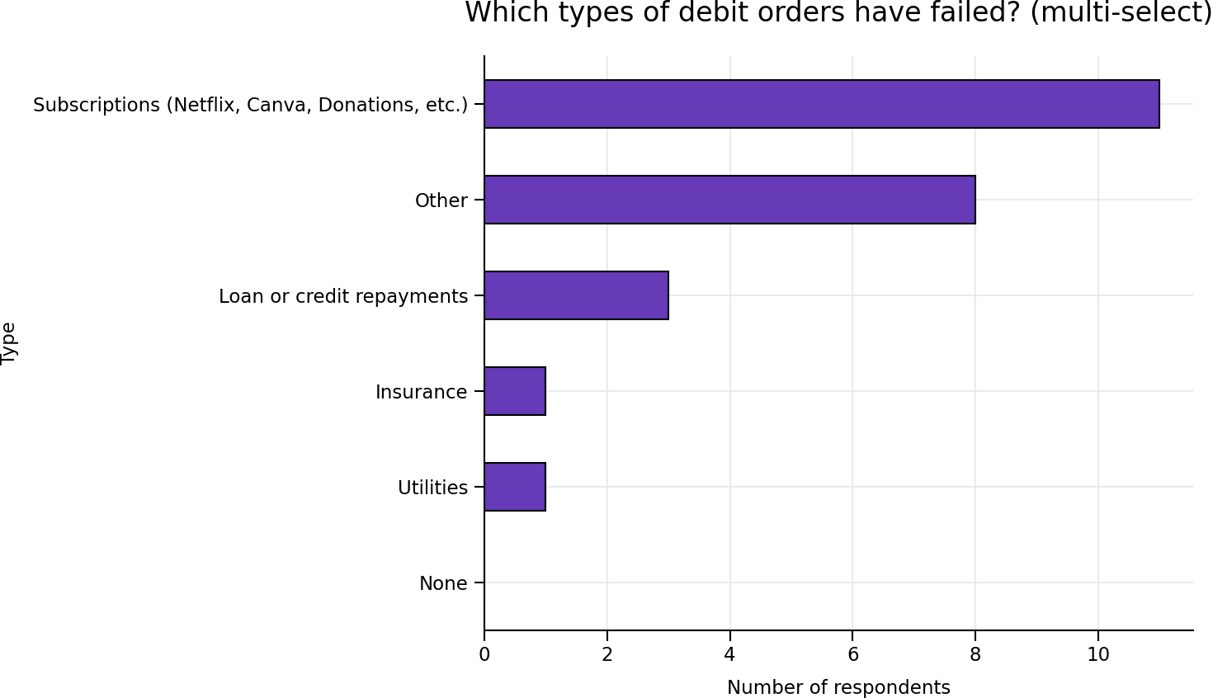Multi-select analysis showed that the debit orders most prone to failure were:

Although respondents in the survey primarily associated missed debit orders with subscription services, a separate dataset of transaction‑level performance reveals that **Insurance (73.37% success rate)** and **Loan Repayments (79.20%)** are the most frequently missed debit orders in real-world processing. This discrepancy highlights a meaningful behavioural insight: consumers may underestimate failures in high‑value categories while more vividly recalling unsuccessful subscription payments.

### 6.4 Consequences of debit order failures

Participants reported experiencing multiple negative consequences following failed debit orders:

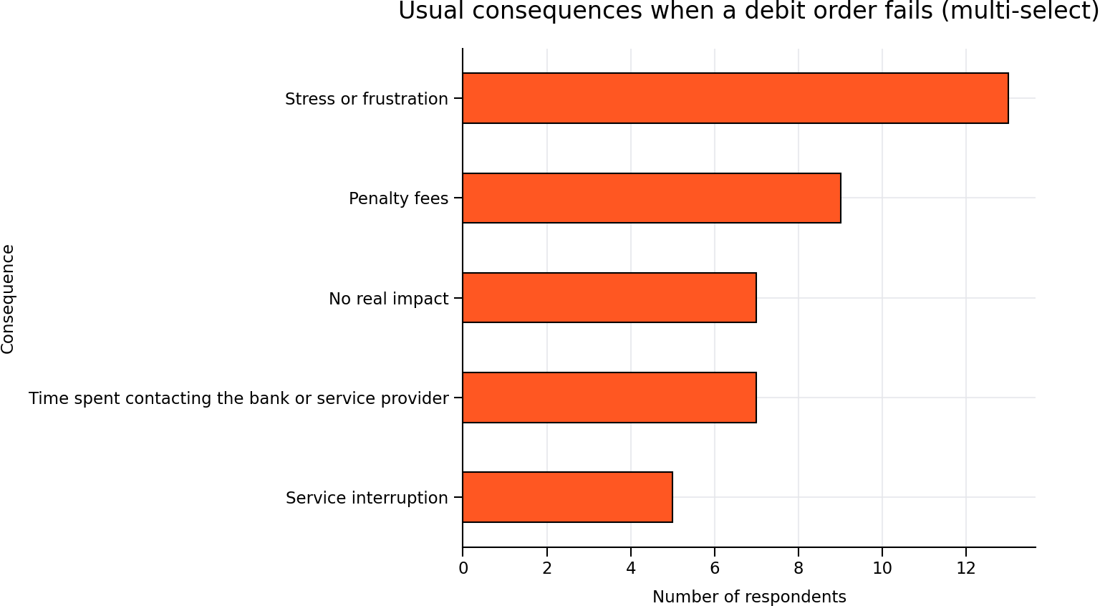

Furthermore, respondents who reported a debit order “bouncing” due to insufficient funds had a **higher likelihood of incurring penalty fees (35.7%)** compared to those who did not experience a bounce (26.7%).

### 6.5 SATISFACTION WITH Bank support

Most respondents (**55.2%**) reported that they **do not feel supported** by their banks when debit orders fail, while only **20.7%** felt supported. Additionally, **20.7%** indicated that repeated failures negatively affect their perception of their bank, with **37.9%** unsure.

However, **86.2%** stated that **fewer unexpected debit order failures would improve their trust** in their bank, highlighting a meaningful opportunity for banks to restore customer confidence.

### 6.6 DEMAND FOR A PREDICTIVE Debit-order system among fnb customers

To assess demand for a predictive debit‑order‑failure system specifically within **First National Bank (FNB)**’s customer base, survey responses regarding the usefulness of advance debit-order failure notifications were analysed alongside respondents’ primary banking affiliations.

Across the full sample, **86.2%** of respondents indicated that advance notice of a likely debit‑order failure would be useful, with only **3.4%** stating it would not be useful. When isolating responses by banking institution, a consistent pattern of strong demand emerges.

**FNB Customer Group**

FNB represented the largest customer segment in the survey, with **11 respondents** identifying FNB as their primary bank (survey was random and not shared on any FNB associated groups). Within this group:

* 81.8% (9 out of 11) indicated that advance notification would be useful.
* The remaining respondents indicated “Maybe”, with no FNB customers rejecting the usefulness of such a service.

### **Comparative Insights Across Banks**

An analysis of all banks represented in the dataset shows that demand for predictive alerts is **consistently high regardless of banking institution**, but particularly pronounced among the major retail banks:

* Customers from **Absa, Capitec, Nedbank, and Standard Bank** all showed **100% usefulness agreement**, although sample sizes were smaller.
* FNB customers showed an **81.8% usefulness agreement**, the highest among banks with a substantial number of respondents (n=11).  
   (Based on the expanded bank‑response mapping from the dataset.

This strongly suggests that **FNB customers are just as motivated—if not more so—than other bank groups** to adopt a predictive debit‑order system.

### **Interpretation for FNB**

### Two insights are particularly relevant for positioning **Flowguard** within FNB:

* **High demand meets low awareness:**  
  Despite the high demand, **most respondents (58.6%) indicated that their bank does *not* currently offer such a service**, and a further **34.5% were unsure**. Only **6.9%** believed their bank offered predictive debit‑order support.  
   This suggests a substantial awareness gap and market opportunity for FNB to lead in this space.
* **FNB customers experience the same pain points:**  
  FNB respondents reported:
* Exposure to timing unpredictability
* Incidences of debit order failures
* Stress and frustration associated with failed debit orders  
   These trends mirror the broader sample, confirming that **FNB clients face the same systemic issues** and would benefit directly from predictive interventions.

### **Conclusion**

The combined analysis demonstrates that **FNB customers show a strong and quantifiable appetite for a predictive debit‑order‑failure system**, with more than four‑fifths expressing support for such functionality. Demand is aligned with broader trends across all banks, but FNB’s larger represented customer base provides clearer evidence of meaningful adoption potential.

This reinforces the strategic viability of implementing **Flowguard** within the FNB environment as a high‑impact, customer‑centric innovation capable of improving trust, reducing unexpected debit‑order failures, and delivering proactive financial guidance

## The FlowGaurd

* What Cashflow Assurance is
* What it is not
* High level visual here potentially

## Debit Order Assurance

The Debit Order Assurance Notification System introduces a push-based alert mechanism that supplements existing tracking features by notifying customers of upcoming financial commitments in advance of processing.

## Data Architecture

The system would employ a hybrid data model combining verified mandate information with predictive analytics:

### Mandated Obligations

The system would leverage existing DebiCheck and other approved debit order mandate data to deliver 100% accurate notifications for fixed bank-contracted payments. This ensures reliability for recurring obligations such as bond repayments, insurance premiums, and subscription services processed through formal mandate agreements.

### Predictive Analytics for Non-Mandated Payments

For recurring payments without formal mandates (such as third-party subscription services), the system would utilise historical transaction data already powering nav»Money functionality. By analysing three months of payment patterns, the system would be able to accurately identify and flag recurring obligations with high confidence.

## Notification Framework

### Timing and Customisation

Customers receive notifications two days before each debit order is scheduled to process. This default timing balances advance warning with relevance, while remaining fully customisable to individual preferences ranging from one to five days in advance.

### Delivery Channels

Notifications are to be delivered through multiple channels to ensure maximum reach and reliability:

* **Mobile banking app push notifications** - primary channel for app users integrated with InContact in-app notifications.
* **SMS** - backup channel and option for customers without the app
* **WhatsApp** - planned for future implementation on an opt-in basis

This multi-channel approach ensures customers receive timely alerts regardless of their preferred engagement method.

### Customer Impact

The notification system fundamentally shifts customer behaviour from reactive crisis management to intentional financial planning. By providing advance visibility of upcoming obligations, customers can proactively ensure sufficient funds are available, thereby avoiding failed payments, penalty fees, and credit score damage.

## Enhanced nav»Money Dashboard

### Upcoming Obligations View

It is proposed that a new section within nav»Money be added to provide customers with a consolidated list of all debit orders due. While debit order mandates are currently visible in the profile section of the mobile banking app, this enhanced view delivers a contextual, action-oriented presentation specifically designed for cashflow management and budgeting purposes.

### Dashboard Capabilities

From the nav>>Debit Orders page, customers can:

* **Customise notification timing** for individual debit orders. For example, five days' notice for rent or mortgage payments and one day for entertainment subscriptions
* **The ability to toggle notifications on or off** for specific obligations based on personal preference
* **View projected balance impact** showing whether customers would have a shortfall to cover the upcoming debits.
* **The ability to take immediate action** if they are in a shortfall, by applying for a buffer to cover the upcoming obligations.

## Competitor Analysis

A competitor analysis was conducted to assess how major banks competing with FNB integrate their money management (MM) tools with transaction notification systems, with a particular emphasis on pre-emptive debit order alerts. The objective is to understand how effectively each institution enables customers to proactively manage their finances through a combination of predictive insights, budgeting capabilities, and real-time alerts. By examining the functionality, strengths, and shortcomings across these competitors, this analysis highlights areas where FNB maintains a competitive advantage, as well as opportunities for enhancement. These insights ultimately support FNB in strengthening customer financial awareness and driving deeper engagement with existing products

|  |  |  |  |  |  |  |
| --- | --- | --- | --- | --- | --- | --- |
| Bank | Money Management (MM) Tool | MM Tool Overview | Transaction Notification System | Predictive Debit Order Alerts‑Order Alerts | Distinguishing MM or Notification Feature | Gaps |
| FNB | **nav>>Money** | Tracks & categorises spend; supports auto & manual budgets; predicts safetospend and month end balances‑to‑spend and month‑end balances | **InContact** – SMS & in-app alerts for real-time transactions, with account balances included‑app alerts‑time | **No** - real-time only‑time only | Predictive balance forecasting that can factor in future payments like debit orders and recurring commitments | Missing an awareness / proactive element; users must constantly manually check dashboards to stay ahead |
| Discovery Bank | **Financial Analyser** | Categorises spend; supports manual & automated budgets; limited predictive financial insights | Email & in-app alerts for real-time transactions, with account balances included‑app alerts‑time | **Yes –** Mandated debit orders | Offers multiple debit order alerts that notify users of upcoming debit amounts and account balances before debits‑order alerts that notify users of upcoming debit amounts and | Missing deeper predictive budgeting and cash‑flow projections |
| Capitec | **None** | Not Applicable | SMS alerts for real-time transactions.‑time | **No** - real-time only‑time only | None identified | Overall, lacks money management insights. |
| ABSA | **ABSA Savings Coach** | Personalised goals that rewards achieving said goals. Autosaver tool that saves money from each transaction. No extra costs. Tracks progress. | **NotifyMe** – SMS, email & in-app alerts for real-time transactions, with account balances included app alerts time ‑app alerts‑time | **No** - real-time only‑time only | Users can opt‑in for daily or weekly balance updates |  |
| Standard Bank | **Money Movements, Future Payments & Budget Manager** | Tracks spend & inflows; supports manual budgeting; shows expected payments over 14‑ and 30‑day periods | **MyUpdates** – SMS & in-app alerts for real-time transactions, with account balances included‑app alerts‑time | **No** - real-time only | Dashboard surfaces expected payments at multiple levels (summary totals to individual upcoming payments) | Predictive dashboard requires manual addition and lacks visibility. Users are not pushed with proactive notifications |
| Nedbank | **MoneyTracker** | Tracks spend & inflows; supports manual budgets; no predictive forecasting | SMS & in-app alerts for real-time transactionsapp alerts time ‑app alerts‑time | **Unclear** | None identified | Missing predictive MM elements and notification features |

From the competitive landscape, it is evident that FNB leads in predictive budgeting through features such as ‘My Available Funds’, which incorporates expected payments into a customer’s projected balance. However, the transparency behind which payments are included in this calculation is limited. In contrast, Standard Bank’s Future Payments feature offers strong visibility into upcoming transactions, presenting them clearly even though it lacks FNB’s predictive balance capability. Additionally, introducing features like Discovery Bank’s proactive debitorder notifications could further enhance the nav>>Money experience and significantly strengthen FNB’s position in empowering customers with timely, actionable financial insights. Order‑ notifications could further enhance the nav>>Money experience and significantly strengthen FNB’s position in empowering customers with timely, actionable financial insights.

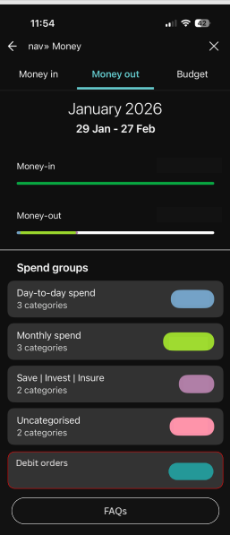

## Predictive Overdraft (Component 2)

## Decision Models & Logic

The FlowGaurd framework operates as a targeted retention instrument, utilizing FNB's extensive historical transaction data to deliver calibrated short-term liquidity exclusively to established customers. Its decision logic is engineered not for credit expansion, but for deepening relationships and mitigating attrition among FNB's existing client base. The system distinguishes itself through a dual-layer approach: a universally accessible service enhancement via Debit Order Assurance, and a selective credit facility via Predictive overdraft, each governed by distinct eligibility and decision models.

Universal Service Layer

Debit Order Assurance constitutes the primary intervention layer, available to all transactional account holders irrespective of tenure. It functions as a pure service enhancement, carrying no credit risk, designed to pre-empt payment failures through intelligent payment timing orchestration.

The model initiates upon detection of a predicted shortfall by the Instant Cashflow engine. It first assesses the feasibility of rescheduling the offending debit order by referencing a pre-negotiated merchant flexibility matrix. This matrix categorizes merchants by their willingness and ability to accommodate date changes without penalty. The system then calculates an optimal rescheduling date, typically positioned two to three calendar days after the customer's next reliably predicted income event, ensuring sufficient funds are available. Execution occurs via integrated API connections with participating merchants, contingent upon a single customer's consent. This service is offered at zero cost to the customer and is subject to usage limits of two reschedules per merchant per rolling quarter to prevent system abuse.

The History Imperative

Access to the BufferShield credit facility is intentionally restricted, grounded in the principle that predictive reliability requires substantial behavioral data. Eligibility is contingent upon a minimum of **ninety days** of continuous transactional history within the FNB ecosystem. This period allows the system to establish a robust behavioral baseline across three critical dimensions: cashflow rhythm, financial discipline, and past credit conduct. This requirement deliberately excludes new-to-bank customers, focusing on the value proposition on reinforcing the loyalty of an established, demonstrably understood client base.

Retention Value Scoring Model

Central to the Predictive Overdraft decision logic is the Retention Value Score (RVS), a composite metric designed to quantify a customer's long-term relationship equity and vulnerability to attrition. The RVS is calculated as follows:

RVS = (0.30 × Relationship Tenure Score) + (0.25 × Product Penetration Index) + (0.25 × Transactional Activity Score) + (0.20 × Profitability Contribution Factor)

Where Relationship Tenure Score rewards both longevity and recent activity; Product Penetration Index measures the breadth of the banking relationship; Transactional Activity Score assesses engagement volume and frequency; and the Profitability Contribution Factor estimates net revenue across all held products.

This score operates in tandem with an **Attrition Probability Algorithm** that monitors signals such as declining logins, fee inquiry complaints, and competitive product searches. Customers exhibiting a high RVS concurrently with elevated attrition risk are prioritized for BufferShield intervention, transforming the facility into a strategic retention tool.

Repayment Certainty Index and Pricing Calibration

For eligible customers, the system computes a Repayment Certainty Index (RCI), a predictive metric of on-time repayment probability derived from historical data. The RCI synthesis is governed by the formula:

RCI = f (Income Consistency, Balance Management Index, Debit Order Success Rate, Historical Short-Term Credit Performance, Savings Utilization Behavior)

The output is segmented into four decision tiers that directly dictate terms:

* **Tier 1 (RCI ≥ 85):** Automated approval at Prime + 1-2% p.a., with access to the full calculated limit.
* **Tier 2 (RCI 70-84):** Streamlined approval at Prime + 2-3% p.a., with moderate limits.
* **Tier 3 (RCI 55-69):** Approval requiring enhanced disclosure at Prime + 3-4% p.a., with reduced limits.
* **Tier 4 (RCI < 55):** Predictive Overdraft offer declined; customer is directed to alternative solutions.

Dynamic Limit Calculation Engine

Predictive Overdraft limits are not static but are dynamically personalized through a multi-factor calibration engine. The calculation proceeds in three stages:

1. Base Limit Determination: `Base Limit = min((0.20 × Monthly Income), R5,000)`

This establishes a prudent maximum tied to affordability.

2. Retention and Risk Adjustment: `Adjusted Limit = Base Limit × [1 + (RVS / 100)] × [1 - (Attrition Probability / 100)] `

This formula increases limits for high-value, loyal customers while reducing them for those showing exit signals.

3. Progressive Behavior-Based Escalation: Approved limits are released progressively to incent responsible use. A first-time user receives 50% of their Adjusted Limit. This escalates to 75% after three successful repayments, 100% after six, and a premium 125% after twelve or more consecutive successful repayments. This creates a transparent reward pathway for financial reliability.

Model Governance and Performance

The decision models are subject to continuous validation to ensure alignment with retention and risk objectives. Model performance is tracked monthly against key metrics: retention rates post-intervention, cross-sell uptake following support, and improvements in customer cashflow behavior. Quarterly reviews assess the accuracy of the RCI and the effectiveness of limit calibration, with bi-annual audits of the complete decision logic.

## Abuse & Risk Pressure Testing

Include scenarios like:

* Gaming pending deposits
* Repeated shortfalls
* Intentional timing manipulation
* Systemic month-end risk

# 02

## Financial & Strategic Impact

This section quantifies Flowguard’s potential to avoid costs, protect/expand revenue, and keep balance-sheet exposure tight using only bank-wide debit-order volumes and outcomes from the *Overall Volumes incl Insure* that can be found in data provided by team members of debit-order related BUs.

### 10.1 WHAT THE OPERATIONAL BASE LOOKS LIKE (Bank-wide)

**Cumulative (2024/04 - 2026/01)**

|  |  |
| --- | --- |
| **Submitted Debit Orders** | 233,211,673 |
| **Successful Debit Orders** | 187,642,515 |
| **Overall Success Rate** | 80.46% --> Implied 19.54% failure rate |

**By Channel (Cumulative)**

|  |  |  |  |
| --- | --- | --- | --- |
| **Channel** | **Submitted** | **Successful** | **Rate** |
| **DC (DebiCheck)** | 85,431,900 | 75,131,922 | 87.94% |
| **EFT** | 145,888,796 | 111,094,059 | 76.15% |
| **RM (Registered Mandate)** | 1,890,977 | 1,416,534 | 74.91% |

**Interpretation:** EFT carries the **largest volume and the largest absolute failure count;** it’s the **first place to hunt** for avoided failures and revenue protection. **Note:** Registered mandates have only been around since 2025/06.

## 10.2 COST Avoidance

|  |  |  |  |
| --- | --- | --- | --- |
| Segment (2025/01 - 2026/01) | Current Failures | 1% fewer | 3% fewer |
| Total (All channels) | 12,293,780 | 122,938 | 368,813 |
| DC | 2,404,484 | 24,045 | 72,135 |
| EFT | 9,426,499 | 94,265 | 282,795 |
| RM | 462,797 | 4,628 | 13,884 |

**Cost attachment formula:**

|  |
| --- |
| Cost_Avoided (R)  = Avoided_Failures × [Avg Penalty Fee per fail (R)]  + Avoided_Failures × [Avg Call/Back-office Cost (R)] × [% of fails escalating]  + Avoided_Failures × [Avg Reinstatement/Admin Cost (R)] × [% of impacted services] |

**Tip:** If Finance wants the **fastest quantified win**, price the EFT rows first; that’s where most savings will materialise.

## 10.3 REVENUE GENERATION (PREDICTIVE OVERDRAFT & Cashflow PROTECTION)

Flowguard monetises **at the moment of need** when a shortfall is predicted for a specific upcoming debit (or any other cashflow related issue).

|  |
| --- |
| Overdraft_Revenue (R)  = [Avoided_Failures_funded]  × [Avg Top-up Amount (R)]  × [Avg Utilisation Days / 365]  × [Effective Annual Rate] |

Where

* **Avoided_Failures_funded** = Avoided_Failures × [% of customers who accept the funding option]
* **Effective Annual Rate =** applicable interest (and appliable fees) net of waivers

## 10.4 Revenue protected from successful collections

Every avoided failure also **protects** the underlying product revenue (premiums, repayments, subscription-linked fees).

|  |
| --- |
| Revenue_Protected (R)  = Avoided_Failures × [Avg Debit Amount (R)] × [Product Margin %] |

## 10.5 BALANCE SHEET EXPOSURE (TIME-Bound, capped)

Flowguard is designed to **minimise risk** by matching credit to verified, near‑term debit needs:

* **Time‑bound exposure** — top‑ups typically last **24–72 hours** until the debit clears.
* **Capped amounts** — limited to the **specific shortfall** (not full facility drawdowns).
* **Policy limits by channel/merchant** — prioritise high‑volume EFT flows first to maximise ROI without expanding risk footprint.

**Exposure monitoring template:**

|  |
| --- |
| EAD_Flowguard (R)  = Σ [Top-up Amount_i × (Avg Days Outstanding_i / 365)] |

## Competitive and strategic positioning

This section outlines why Flowguard works uniquely well in FNB’s ecosystem because it relies on deep internal data—like customer cash‑flow patterns, debit‑order timing, and credit‑behaviour signals—that only FNB can see and model accurately. Competitors may copy the idea, but they can’t replicate the underlying prediction engine, because their MM tools are surface‑level and lack the integrated forecasting, alerting, and credit‑pathing capabilities FNB already has. By solving a major customer pain point proactively, Flowguard creates a level of daily usefulness that strengthens loyalty and makes FNB significantly harder to replace.

## 11.1 Flowguard relies on data that only FNB has

Flowguard needs deep, fine-grained visibility into:

* Customers' daily cash-flow patterns
* Debit-order timing across rails
* Balance trajectories and volatility
* Salary deposits and spending patterns
* Credit facility utilisation

These signals live inside FNB’s core ecosystem.

Because the model learns from *FNB-specific* behaviour, accuracy is tied directly to FNB’s environment.

Competitors cannot access our behavioural data, so even if they copy the concept, they cannot directly copy the capability.

## 11.2 FNB ALREADY HAS THE BUILDING BLOCKS – THE PRODUCT FITS NATURALLY

FNB has:

* **InContact** (real-time alerts)
* **Nav>>Money** (Budgeting + My Available Funds)
* **Rich transactional history**
* **Credit rails (temp loans, overdrafts, credit card)**
* **Advanced internal data science infrastructure**

Flowguard uses all four in one integrated loop:

In the case of debit orders: **Predicts debit-order risk --> alerts the customer --> offer right funding option --> ensures debit order success.**

No other bank has this combination of forecasting + alerting + credit rails already working together.

## 11.3 OTHER BANKS FOCUS ON VISIBILITY, NOT PREDICTION

Flowguard builds on FNB’s already strong money‑management ecosystem by adding a predictive layer that anticipates debit‑order risks before they happen, turning existing tools like My Available Funds and InContact into a proactive safety net. By integrating debit‑order forecasting with real‑time alerts and seamless access to funding options, FNB can offer customers a more complete and empowered way to manage their cashflow. This added predictive intelligence elevates the overall banking experience, making FNB even more indispensable in customers’ daily financial routines.

## 11.4 FLOWGUARD CREATES Ecosystem LOCK-IN THROUGH Usefulness – NOT Stickiness

Once customers experience:

* early warnings of upcoming failures
* predicted future balances
* personalised credit paths at the moment of need

Flowguard becomes something they **depend on**, not something they “check”.

A customer who avoids fees, stress, and failed debit orders **because of FNB** becomes significantly less likely to leave, because the benefit is tied to:

* their FNB income behaviour
* their FNB debit‑order patterns
* their FNB credit products
* their FNB notification stream
* their FNB cash‑flow data

None of this transfer cleanly if they move banks.

## 11.5 Competitors CAN COPY THE Idea, but not the execution

They would need to rebuild:

* predictive balance modelling
* debit-order risk scoring
* real-time shortfall simulation
* credit decisioning integration
* notification‑system integration
* risk and affordability guardrails

These require years of internal data, regulatory alignment, and system redesign. In practice, most banks struggle just to unify their MM tools and notifications. Flowguard is a **multi‑layer system**, not a feature.

# 03

## roadmap

Phased rollout:

* Phase 1
* Phase 2
* Phase 3

Include:

* What is reused
* What is new

## SUCCESS metric

Prove how we know it worked.

* Predictive Overdraft utilisation vs repayment rate
* Reduction in debit order failures
* Reduction in involuntary churn

# APPENDIX A

A.1 OVERVIEW

## A.2 Initial Brainstorming & Exploration

Our process began with a comprehensive audit of FNB’s customer touchpoints, ranging from mobile and online banking to physical branches, ATMs, and backend systems. By casting a wide net across these diverse domains, we aimed to surface high-impact opportunities before narrowing our focus to the most critical pain points. Through this discovery phase, we determined that all identified challenges converged into three areas: Security, Operations, and Cash Flow Management.

|  |
| --- |
| **DOMAIN 1: Security** |
| **Ideas Explored:**  • **Prepaid Accounts:** Virtual cards linked to prepaid accounts for additional fraud protection and possible budgeting use.  • **Session Management:** Auto-logout when phone is locked to prevent unauthorised access |

|  |
| --- |
| **DOMAIN 2: Operations** |
| **Ideas Explored:**  • **Customer Effort Index:** Identify high-friction touchpoints across FNB’s banking channels and measure task difficulty through analytics.  • **Rural ATM Access:** Expand infrastructure for cash deposits in underserved areas |

|  |
| --- |
| **DOMAIN 3: Cash Flow Management** |
| **Ideas Explored:**  • **Proactive Notifications:** Alerts customers 2-3 days before debit orders due  • **Predictive Overdraft:** Machine learning model predicting shortfalls and offering tailored short-term overdraft cover |

## a.3 Impact Matrix & Prioritisation

To prioritise which domain to pursue, we developed a decision matrix evaluating each domain against seven criteria areas, which can be found in Table

|  |  |  |  |
| --- | --- | --- | --- |
| **Evaluation Criteria** | **Domain 1: Security** | **Domain 2: Operations** | **Domain 3: Cash Flow** |
| **Customer Breadth** | **Low-Medium** | **Low-Medium** | **High** |
| **Financial Impact** | **Low**  **Potential fraud (rare)** | **Low-Medium**  **Indirect costs** | **High** |
| **Implementation Complexity** | **Low**  **App-only changes** | **High**  **Physical infrastructure or complex backend processes** | **Medium-High**  **App and backend changes** |
| **Time to Value** | **Fast** | **Slow** | **Moderate** |
| **Measurability** | **Medium**  **Fraud incident tracking** | **Low**  **Difficult attribution** | **High**  **Clear transaction data** |
| **Problem Classification** | **Bug/Feature**  **Technical fixes and minor feature additions** | **Infrastructure**  **Capital and Resource Investment** | **Experience Design**  **Systemic journey** |
| **Revenue Impact** | **Neutral**  **No revenue loss** | **Unknown**  **Indirect benefits** | **Negative**  **Loss of income from penalty fees** |
| **Weighted Score** | **12/21** | **10/21** | **17/21** |

|  |  |  |  |
| --- | --- | --- | --- |
| **Key: Colour and Associated Score** | **1** | **2** | **3** |

A.3.1 DISCUSSION

Using the impact matrix to refine our problem focus area, we identified several topics that did not warrant further customer engagement. These areas were deprioritised because they lacked sufficient impact, relevance, or alignment with strategic objectives.

**PREPAID DIGITAL CARD**  
This would be a product feature addition addressing customer anxiety around security and spending control. Existing workarounds exists, such as having dedicated virtual cards for various spend areas with unique limits attached to each. The virtual cards also provide adequate security using dynamic CVVs. This area would be a niche use case affecting a limited customer segment.

**SESSION MANAGEMENT**   
This is a security vulnerability requiring engineering remediation and does not directly affect customer engagement. This issue would likely have a low incidence rate and requires a binary solution which has limited strategic value.

**RURAL CASH DEPOSITS**  
An infrastructure challenge requiring substantial capital investment and the solution complexity extends beyond customer engagement optimisation and primarily serves a niche rural segment.

**CUSTOMER EFFORT INDEX (CEI)**  
The diagnostic framework would identify friction points but does not constitute a tangible customer deliverable. The CEI functions as a measurement tool rather than a solution in itself and would require subsequent interventions to address identified issues.

SELECTED PRIORITY AREA: CASH FLOW MANAGEMENT

Cash flow management emerged as the clear strategic priority based on four reasons:

* Customers experience this pain point daily rather than hypothetically. Unlike future benefits, like enhanced security, or abstract improvements, cash flow shortfalls and failed debit orders represent an immediate, tangible problem causing financial stress in real time.
* Improving cash flow management and reducing failed debit order would have a far wider reach than the use cases addressed by alternative domains.
* The average overdraft fee multiplied by monthly occurrence frequency represents a measurable, recurring financial burden directly impacting customer wellbeing. Unlike abstract efficiency gains or potential fraud losses, this constitutes real money leaving customer accounts every month.
* There is comprehensive transaction data that can provide clear baseline metrics including overdraft frequency, fee revenue, and timing patterns. Success can be measured objectively through reduction in overdraft incidents, decrease in fees paid, and improvement in nav»Money engagement metrics.